Control flow

In the programs we have seen till now, there has always been a series of statements and Python faithfully executes them in the same order. What if wanted to change the flow of how it works? For example, you want the program to take some decisions and do different things depending on different situations such as printing 'Good Morning' or 'Good Evening' depending on the time of the day?
As you might have guessed, this is achieved using control flow statements. There are three control flow statements in Python - if, for and while.

If statement:

The if statement is used to check a condition and if the condition is true, we run a block of statements (called the if-block), else we process another block of statements (called the else-block). The else clause is optional.

Syntax
1) Single if
if expression:
statement(s)

2)If else-block
if expression:
statement(s)
else:
statement(s)

3)elif statement
if expression1:
statement(s)
elif expression2:
statement(s)
elif expression3:
statement(s)

Example:
If we want to design a simple calculator which performs addition,substraction,multiplication and division,then we can easily do this by using if else statements.
CODE:

num1= int(input("Enter a number:"))
num2= int(input("Enter one more number:"))
print("What do you want to carry out: \n a)Addition \n b)Substraction \n c)Multiplication \n d)Division \n Enter your choice")
choice = input()
if choice =='a':
result = num1+num2
elif choice=='b':
result = num1-num2
elif choice =='c':
result = num1*num2
else:
result = num1/num2
print("Result is", result)

How it works?
The first statement takes input from user and store it in variable num1.input() is used to take keyboard input. Since input() treats the entered value as string. It is converted into integer using int().Similarly another number is stored in num2 variable. Third line is a print statement .
In the subsequent statement the “choice” is stored in choice variable.
Now comes the if else statement.
The if statements checks for various conditions and if a particular condition is satisfied, the following statement is executed.
eg. if the entered value of choice is 'a' , then the statement result = num1+num2 is executed
otherwise if the entered value is 'b' , then the statement result = num1-num2 is executed and this process goes on .

LOOPS

In general, statements are executed sequentially. The first statement in a function is executed first, followed by the second, and so on. There may be a situation when you need to execute a block of code several number of times.
Programming languages provide various control structures that allow for more complicated execution paths.
A loop statement allows us to execute a statement or group of statements multiple times .
Python provides following types of loops: for loop and while loop .

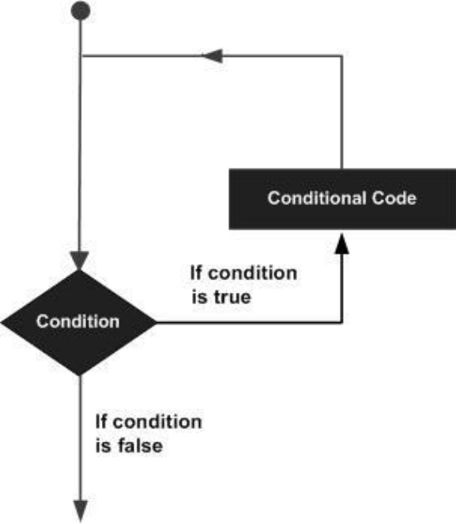

The for loop :

The for..in statement is another looping statement which iterates over a sequence of
objects i.e. go through each item in a sequence.
Syntax:
for iterating_var in sequence:
statements(s)

Eg.

for i in range(2,6):
print(i)
else :
print("Loop is over.")

How it works?
In the above program , we are printing a sequence of numbers from 2 to 10 using for loop and the range() function.
What is the function of range() here? range() returns a sequence of numbers starting from the first number and up to the second number. For example, range(1,5) gives the sequence [1,2,3,4,5].By default range takes a step count of 1 ,but if we want the step to be different we can achieve that by supplying another third number in the range function eg range(1,7,2) will give 1,3,5 as sequence,note that the range extends upto the second number but it doesn't include the second number.
The for loop iterates over this range i.e. for each value of i (here 2,3,4,5) the statement- print(i) is executed. Else part is optional ,it isn't necessary to use else after for loop . The for loop is used when we know the number of iterations that the loop needs to perform.

while loop

The while statement allows you to repeatedly execute a block of statements as long as a condition is true. A while statement is an example of what is called a looping statement. A while statement can have an optional else clause.

Syntax:

while expression:
statement(s)

Here, statement(s) may be a single statement or a block of statements. The condition may be any expression, and true is any non-zero value. The loop iterates while the condition is true.

When the condition becomes false, program control passes to the line immediately following the loop.
In Python, all the statements indented by the same number of character spaces after a programming construct are considered to be part of a single block of code. Python uses indentation as its method of grouping stateme
nts.

Example:
'''Print a table of 4 using while'''

i=1
while i<11:
j=4*i
print("4*",i,"=",j,"\n")
i+=1
else :
print(“Table is complete”)

How it works?
In this program we are printing a table of 4 using while loop . The first statement initializes variable i to 1 .Next four statements constitute while loop.
“while i<11” checks if i is less than 11 or not. If the condition is found to be true ,then the next three statements are executed.In next statement variable j is assigned 4*i.and the result is printed . Subsequent statement increments the value of i by 1. The control again goes to the statement “while i<11” and it checks whether the incremented value is less than 11. If found to be true it executes the next three statements and this process goes on until the check expression results into false.
Once i>=11 loop is terminated and the control passes to the statement just after while loop (here,else statement).
Note that else part is optional

